**Lesson 9 Demo 1**

**Managing Sensitive Files with Ansible Vault**

**Objective:** To manage sensitive files using Ansible Vault

**Prerequisites:** You need to have Ansible installed and setup to proceed with this demo. If you don’t have it installed, refer to demo 1 of lesson 2.

**Tools required:** Ubuntu terminal and Ansible

**Steps to be performed:**

1. Creating newly encrypted files
2. Encrypting existing files
3. Viewing encrypted files
4. Editing encrypted files
5. Decrypting encrypted files manually
6. Changing the password of encrypted files
7. Running Ansible with vault-encrypted files

**Step 1: Creating New Encrypted Files**

1. To create a new file encrypted with Vault, use the following command where *vault.yml* is the name of the encrypted file that you use to store the sensitive variables

***ansible-vault create vault.yml***

1. You will be prompted to enter and confirm a password

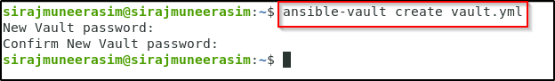

1. Then, Ansible will open an editing window where you can enter your desired contents. To test the encryption function, enter some test text:

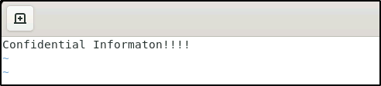

1. Ansible will encrypt the contents when you close the file. If you check the file using the command ***cat vault.yml*** instead of seeing the words you typed, you will see an encrypted block:

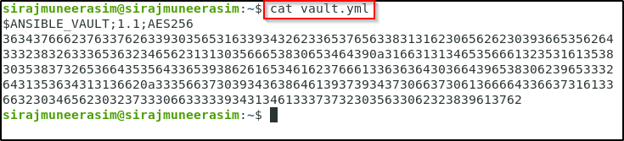

**Step 2: Encrypting Existing Files**

1. You can encrypt an existing file using the ansible-vault encrypt command. Suppose we create an example file for testing using the command

***echo 'unencrypted stuff' > encrypt_me.txt***

1. You can encrypt the existing file using the command

***ansible-vault encrypt encrypt_me.txt***

1. Again, you will be prompted to provide and confirm a password. Afterward, a message will confirm the encryption

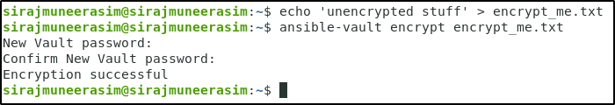

1. You can see the following output on running the ***cat encrypt_me.txt*** command

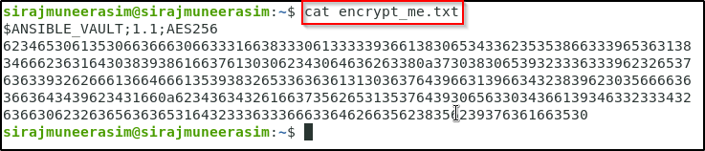

**Step 3: Viewing Encrypted Files**

1. Pass the vault encrypted file to the ansible-vault view command:

***ansible-vault view vault.yml***

1. You will be asked for the file’s password. After entering it successfully, the contents will be displayed:

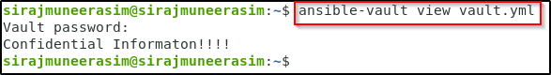

**Step 4: Editing Encrypted Files**

1. Use the below command to edit encrypted files:

***ansible-vault edit vault.yml***

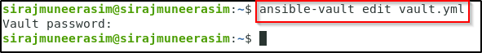

1. You will be prompted to enter a password, after which you can successfully edit the file



**Step 5: Decrypting Encrypted Files Manually**

1. To decrypt a vault encrypted file, use the ansible-vault decrypt command

***ansible-vault decrypt vault.yml***

1. Your file will be decrypted after entering the correct password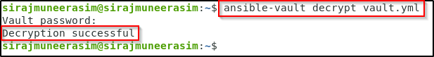
2. On running the ***cat vault.yml*** command you should see the actual contents of the file



**Step 6: Changing the Password of Encrypted Files**

1. Use the following command to change the password of an encrypted file

***ansible-vault rekey encrypt_me.txt***

1. You will be prompted to enter the file’s current password. After entering It, you will be prompted to select and confirm a new password
2. You will receive the following message on successful re-encryption

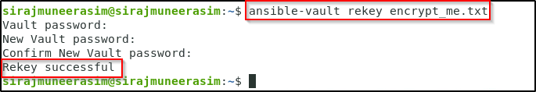

**Step 7: Running Ansible with Vault-Encrypted Files**

1. Let’s first create a vault-encrypted file using the command

***ansible-vault create secret_key***

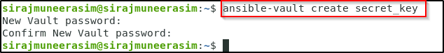

1. Select and confirm a password. Enter the sample contents in the file. Save and close the file



1. Create a temporary hosts file as an inventory using:

***cd /etc/ansible/***

***sudo nano hosts***



1. We will add just the Ansible localhost to it. We will place it in the [database] group to prepare for a later step:

***[database]***

***localhost ansible_connection=local***

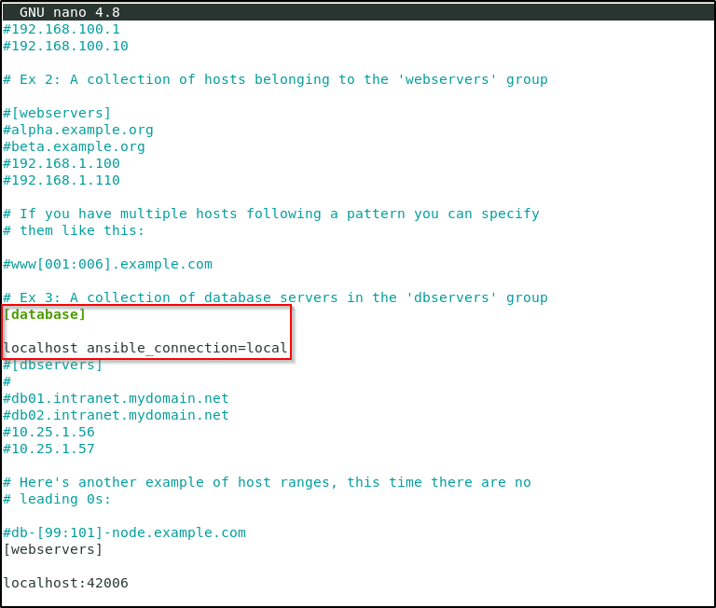

1. Next, create an ansible.cfg file in the current directory if one does not already exist:

***sudo nano ansible.cfg***



1. For now, just add a [defaults] section and point Ansible to the inventory we just created:

***[defaults]***

***inventory = ./hosts***

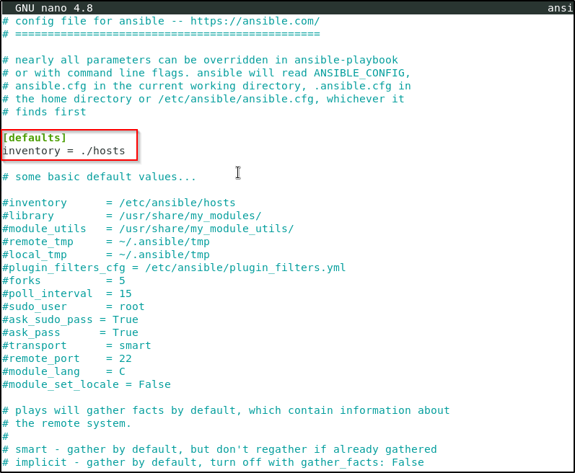

1. Run the following command

***ansible --ask-vault-pass -bK -m copy -a 'src=secret_key dest=/tmp/secret_key mode=0600 owner=root group=root' localhost***

1. Please note that you will have to enter the lab user’s password on being prompted along with the vault password. When the password is provided, Ansible will attempt to execute the task using the Vault password for any encrypted files it finds. Keep in mind that all files referenced during execution must use the same password
2. You will see the following output

